**Hadoop Stock Exchange Case study**

**HDFS Hands-on**

a. Create a folder called /user/training/stock/input in hdfs

*hadoop dfs -mkdir -p /user/training/stock/input*

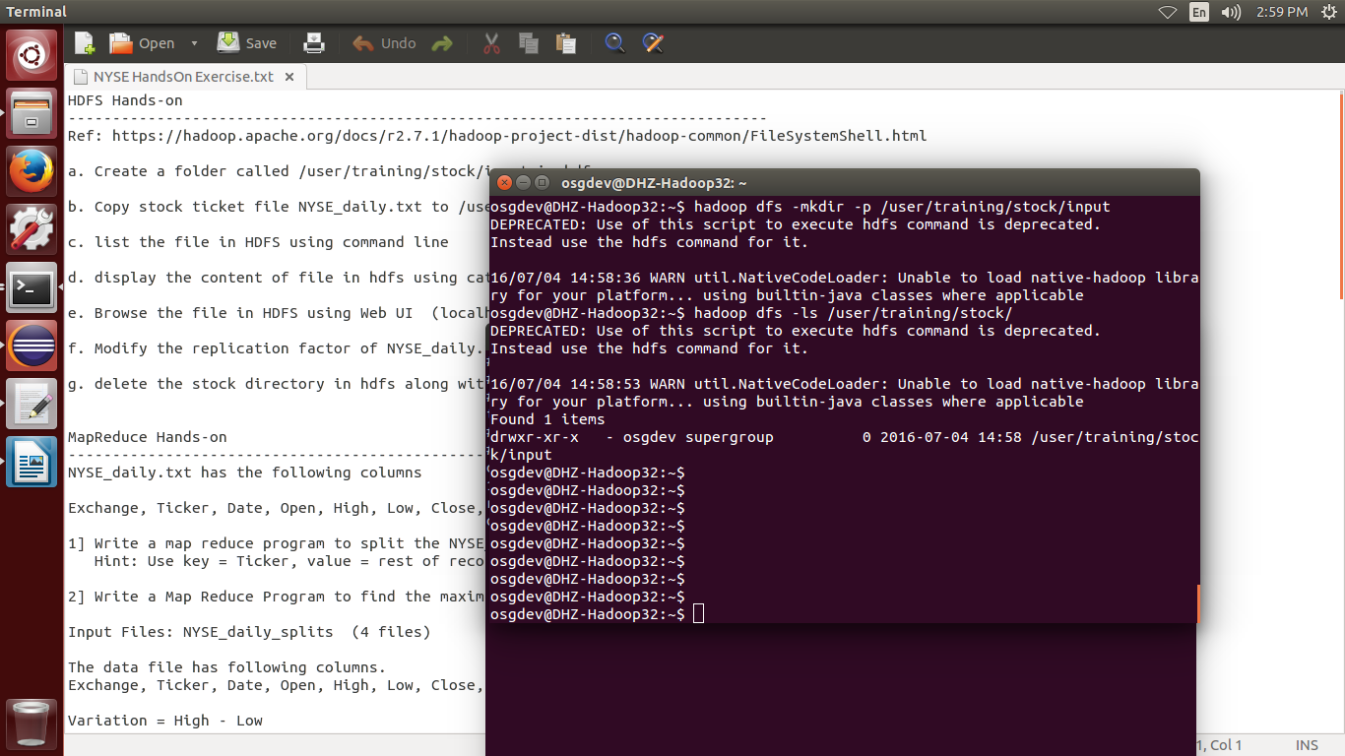

b. Copy stock ticket file NYSE_daily.txt to /user/training/stock/input

*hadoop dfs -put NYSE_daily.txt /user/training/stock/input*

c. list the file in HDFS using command line

*hadoop dfs -ls /user/training/stock/input*

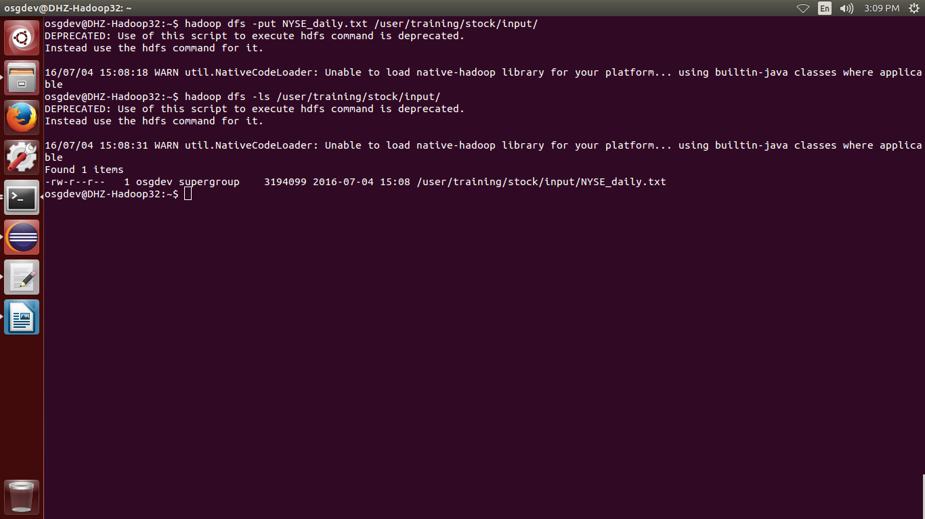

d. display the content of file in hdfs using cat command

*hadoop dfs -cat /user/training/stock/input/NYSE_daily.txt*

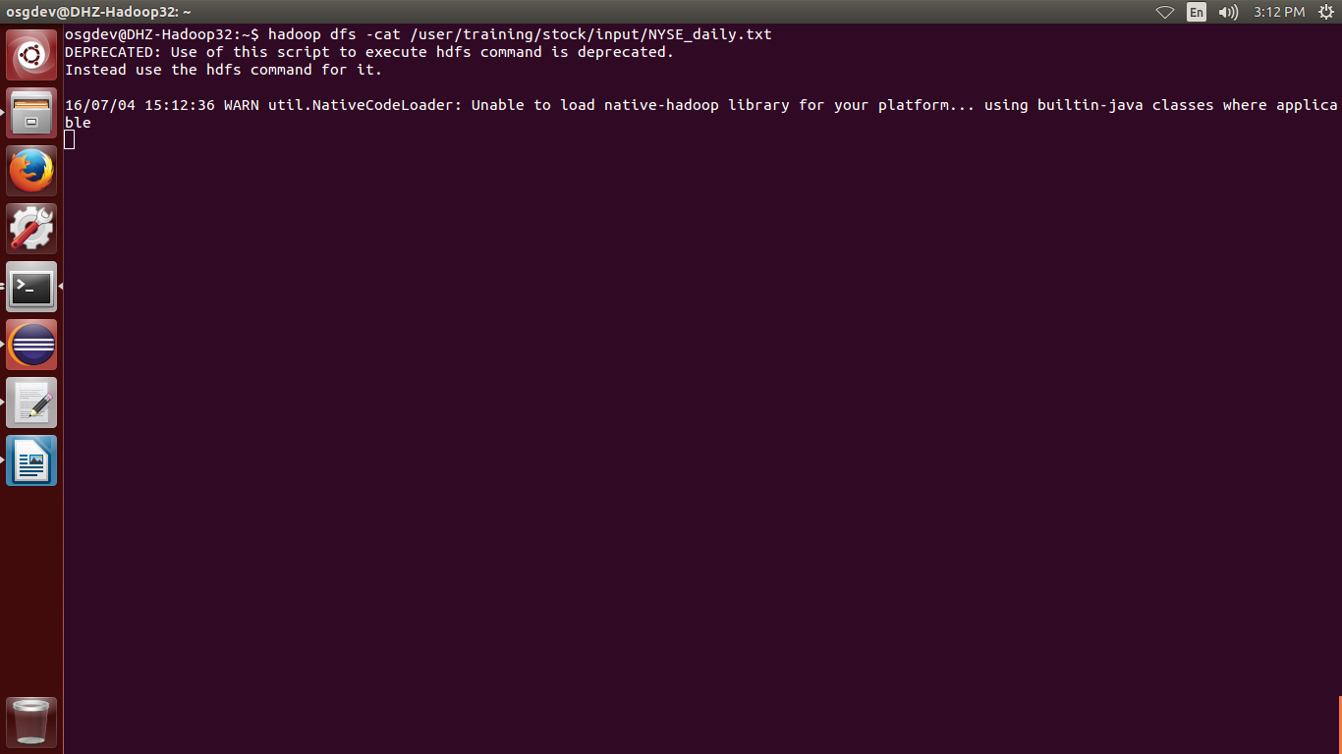

e. Browse the file in HDFS using Web UI (localhost:50070)

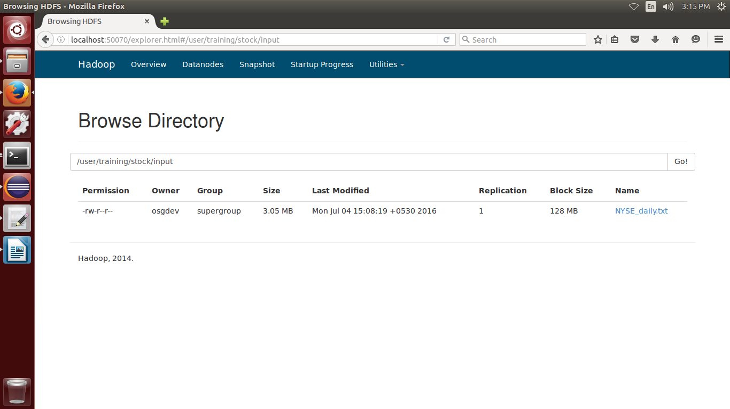

f. Modify the replication factor of NYSE_daily.txt to 2

*hadoop dfs -setrep -R 2 /user/training/stock/input/NYSE_daily.txt*

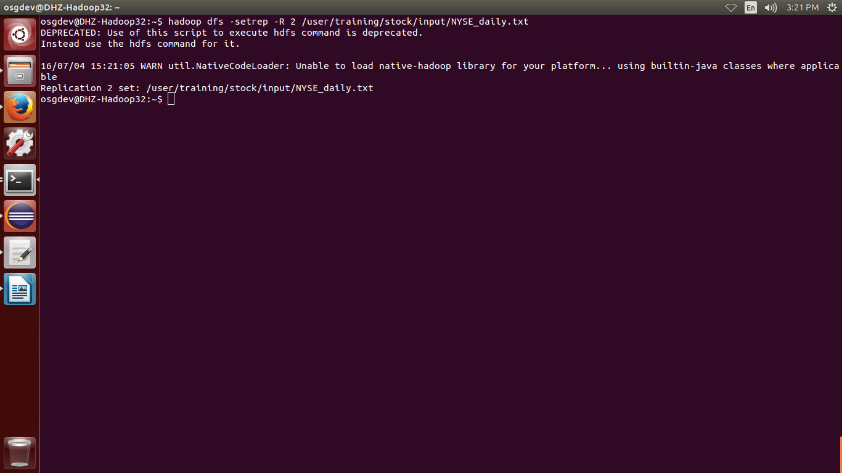

g. delete the stock directory in hdfs along with all sub directories

*hadoop dfs -rmr /user/training/stock*

